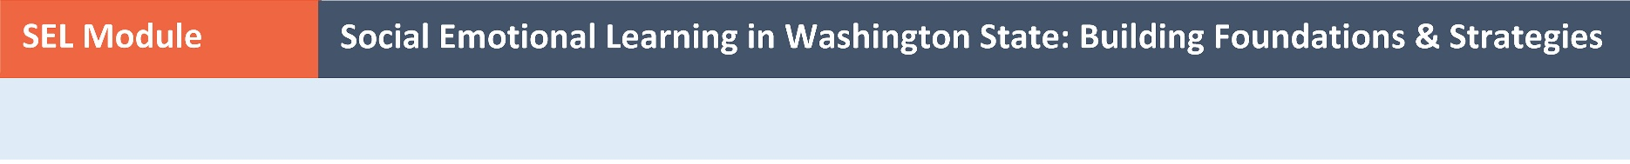
Multilingual Resources on Social Emotional Learning
The Washington Office of Superintendent of Public Instruction (OSPI) has developed several resources to support the implementation of social emotional learning (SEL) in Washington. Many of these resources, listed in the table below, have been translated into Chinese and/or Spanish.
Resource | Description | Translations
Washington Social Emotional Learning K-12 Standards and Benchmarks | One-page handout listing the six SEL standards and corresponding benchmarks. | Chinese  Spanish
Standards Adoption Letter | Letter from the Washington Superintendent of Public Instruction adopting the Washington SEL Standards and Benchmarks. | Chinese  Spanish
Washington State SEL Implementation Guide | Guidance on implementing SEL for individuals who work with children and youth. | Spanish
Washington SEL Implementation Brief: For Education Leaders | High-level guidance on SEL implementation for education leaders. | Chinese  Spanish
Washington SEL Implementation Brief: For Educators | High-level guidance on SEL implementation for educators. | Chinese  Spanish
Washington SEL Implementation Brief: For Parents and Families | High-level guidance for parents and families on how to support students’ social and emotional development. | Chinese  Spanish
Washington SEL Implementation Brief: For Community and Youth Development Organizations | High-level guidance on SEL implementation for youth-serving organizations. | Chinese  Spanish
Washington SEL Implementation Brief: Focus on Culturally Responsive Practices | High-level guidance on culturally-responsive practices and SEL. | Chinese  Spanish
SEL and Equity: Current Issues and Considerations | In-depth resource from Education Northwest on SEL and equity to inform policy and practice in Washington. | Chinese  Spanish

Other organizations that are referenced in the Washington SEL Online Module offer multilingual resources such as resources that are designed to inform parents and families about SEL (e.g., this introductory video from the Collaborative for Academic, Social, and Emotional Learning).

